**Planning Proposal**

**Human Resources Management System**

Proposed By:

Agpoon, Claire

Asistio, Cholo Edmon

Bernadas, Sidney Neo

Caloing, Dario

Garcia, Vince Gelo

Gumangcam, John Lloyd

Gumabon, Ericka

Nogas, Jean

Tandoy, Jhon Michael

**FlowChart**

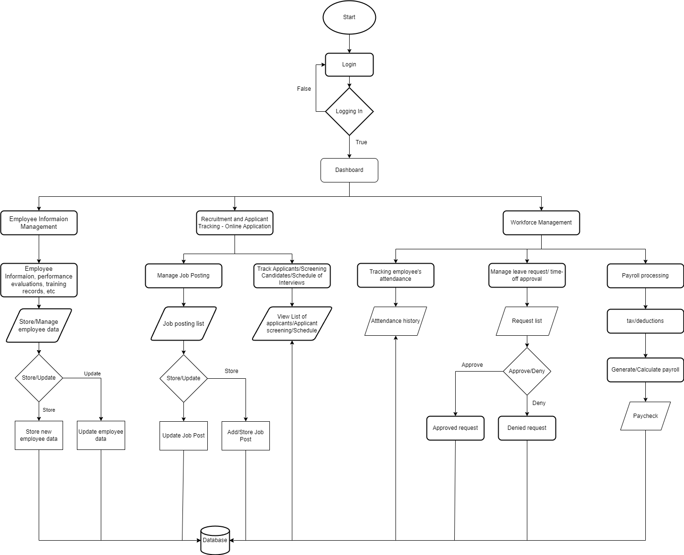

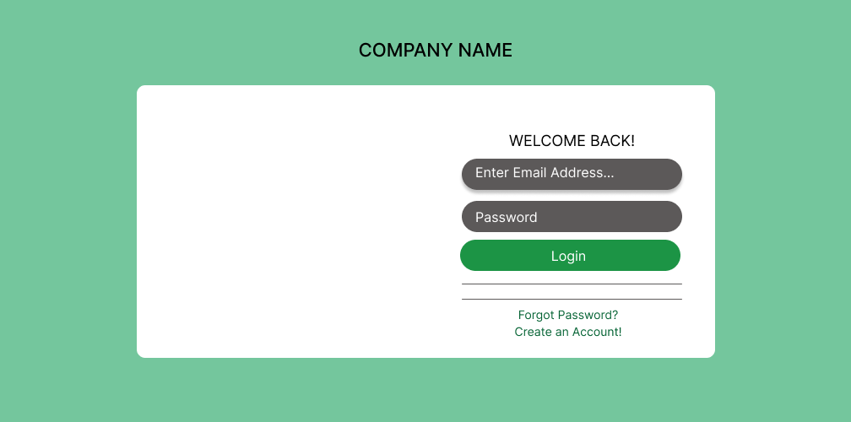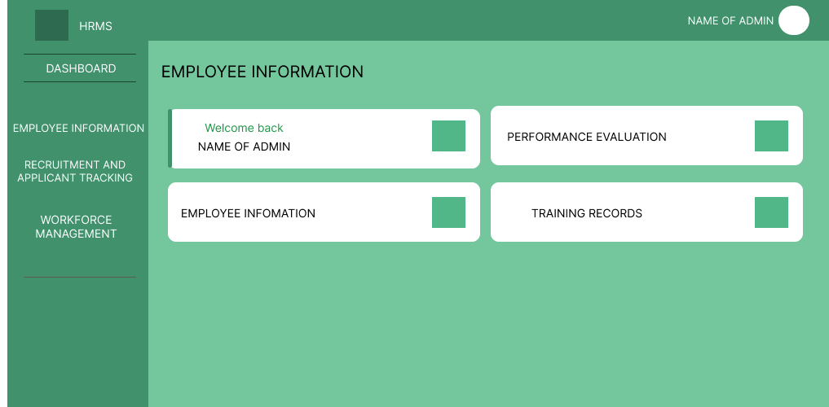**Wireframe (UI)**

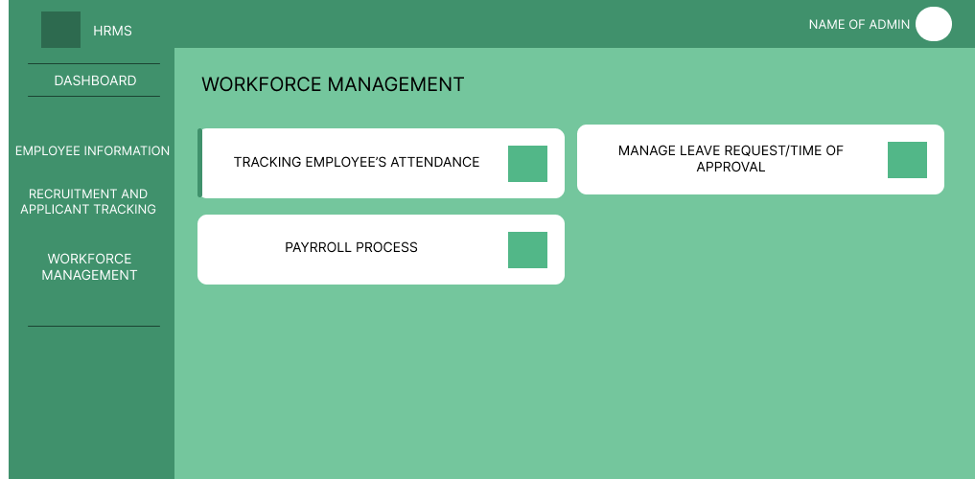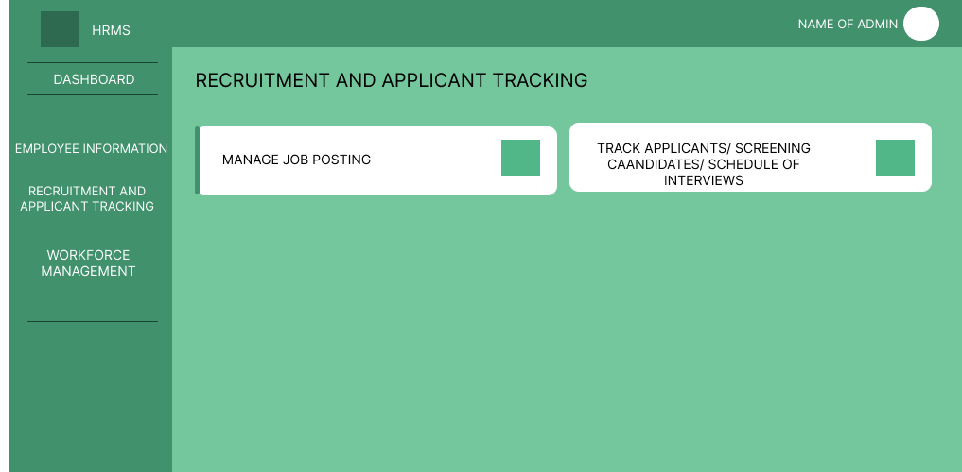

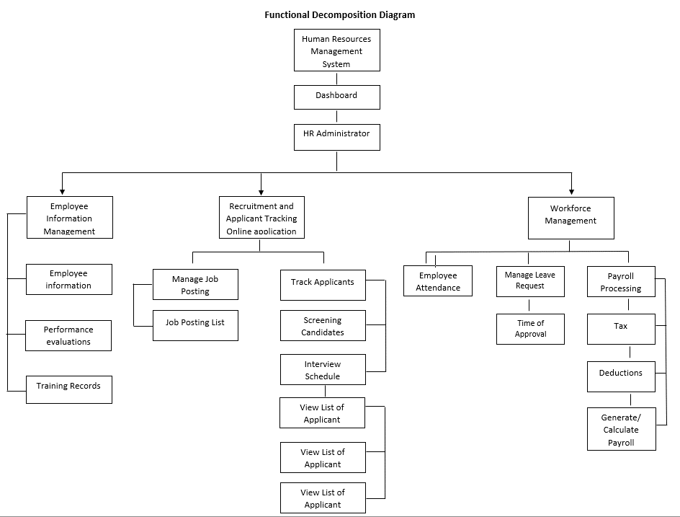**Functional Decomposition Diagram**

**Functional Decomposition List**

**1.0 Dashboard**

**2.0 HR Administration**

**3.0 Employee Information Management**

3.1 Employee Information

3.2 Performance Evaluation

3.3 Training Records

**4.0 Recruitment and Application Tracking Online Application**

4.1 Manage Job Posting

4.2 Job Posting List

4.3 Track Applicants

4.4 Screening Candidates

4.5 Interview Schedule

4.6 View List of Applicant

**5.1 Workforce Management**

5.1 Employee Attendance

5.2 Manage Leave Request

5.3 Time of Approva

5.4 Payroll Processing

5.5 Tax

5.6 Deduction

5.7 Generate / Calculate Payroll